ASSIGNMENT

1.Create a blog or website using Blogspot and WordPress. Customize the theme design and post new article with 500 words.

LINK: [MyStyle Womens Product – MYStyle (wordpress.com)](https://mystylewomensproduct.wordpress.com/2023/10/03/mystyle-womens-product/)

LINK: [Mystyleproduct](https://mystyleproduct.blogspot.com/)

2. Create a New Facebook Business Page and post one

social media poster for your brand.

LINK: [Facebook](https://www.facebook.com/mystyleprodut/)

3. Create and design a social media advertisement poster

using canva.

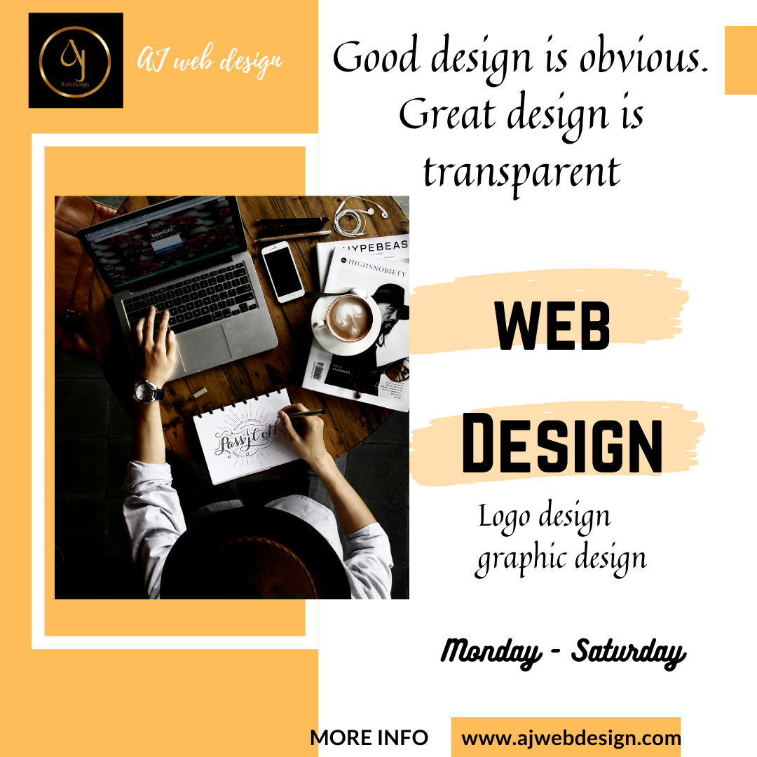

4. Create email newsletter design using MailChimp or canva

tool.

